Supplementary Materials:
Isolation and Biochemical Characterization of Long-Tailed Macaques Aerobic Gut Bacteria from Tinjil Island, Indonesia
Anggitha Tambunan¹, Puji Rianti^{1,2*}, Jepri Agung Priyanto¹, Huda Shalahudin Darusman^{2,3}, Randall C. Kyes^{2,4}

¹Department of Biology, Faculty of Mathematics and Natural Sciences, IPB University. Jl. Agatis, Kampus IPB Dramaga, Bogor, Indonesia
²Primate Research Center, IPB University. Jl. Lodaya II No 5 Bogor, Indonesia
³School of Veterinary Medicine and Biomedical Sciences, IPB University. Jl. Agatis, Kampus IPB Dramaga, Bogor, Indonesia
⁴Departments of Psychology, Global Health, and Anthropology, Center for Global Field Study, and Washington National Primate Research Center, University of Washington. 3980 15th Ave NE Seattle, Washington 98195, USA

*Corresponding author: pujirianti@apps.ipb.ac.id

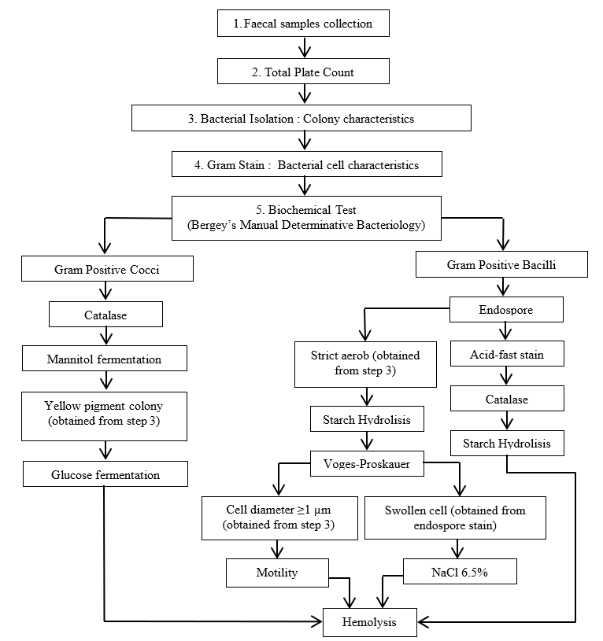
Figure S1. The flowchart of the study methods includes two types of Bergey's Manual of Determinative Bacteriology.

Table S1 Total viable bacteria in four fecal samples of LTM from Tinjil Island, Banten

No. | Sample | Total viable bacteria (CFU/g)
1 | C72 | 2.81 x 10⁹
2 | LB2 | 1.37 x 10⁹
3 | LB3 | 2.18 x 10⁹
4 | RB1 | 1.11 x 10⁹
 | Average | 1.86 x 10⁹
Note: Fecal samples were collected from semi-wild long-tailed macaques onTinjil Island. Samples were labeled as follows: C72 (Cage 7 Sample 2), LB2 (Left Base camp Sample 2), LB3 (Left Base camp Sample 3), RB1 (Right Base camp Sample 1). CFU/g indicates colony-forming units per Gram.

Table S2 Morphological characteristics of bacterial colonies on NA medium
No. | Isolate  Code | Colony Morphology
 |  | Shape | Margin | Colour | Elevation | Transparency | Texture
1 | C72.1 | Irregular | Undulate | White | Flat | Opaque | Viscid
2 | C72.2 | Irregular | Undulate | White | Flat | Opaque | Viscid
3 | C72.3 | Irregular | Undulate | Yellow | Flat | Opaque | Viscid
4 | LB2.1 | Irregular | Entire | White | Flat | Opaque | Mucoid
5 | LB2.2 | Circular | Entire | Yellow | Flat | Opaque | Mucoid
6 | LB2.3 | Circular | Entire | White | Raised | Translucent | Viscid
7 | LB2.4 | Circular | Entire | White | Flat | Opaque | Viscid
8 | LB2.5 | Irregular | Undulate | White | Flat | Opaque | Viscid
9 | LB3.1 | Irregular | Undulate | Light yellow | Flat | Translucent | Viscid
10 | LB3.2 | Circular | Entire | Yellow | Flat | Opaque | Viscid
11 | LB3.3 | Circular | Entire | Light pink | Flat | Translucent | Viscid
12 | LB3.4 | Irregular | Undulate | Light yellow | Flat | Translucent | Viscid
13 | LB3.5 | Circular | Entire | White | Raised | Opaque | Viscid
14 | LB3.6 | Circular | Entire | Light yellow | Raised | Opaque | Viscid
15 | RB1.1 | Circular | Entire | White | Raised | Translucent | Viscid
16 | RB1.2 | Circular | Entire | Yellow | Convex | Opaque | Viscid
17 | RB1.3 | Circular | Entire | White | Raised | Opaque | Viscid
18 | RB1.4 | Circular | Entire | Light pink | Flat | Translucent | Viscid
19 | RB1.5 | Irregular | Undulate | White | Flat | Opaque | Mucoid
Note : Isolate codes represent bacterial isolates obtained from fecal samples of semi-wild long-tailed macaques from Tinjil Island. Isolates include C72.1 (Cage 7 Sample 2 Isolate 1), C72.2 (Cage 7 Sample 2 Isolate 2), C72.3 (Cage 7 Sample 2 Isolate 3), LB2.1 (Left Base camp Sample 2 Isolate 1), LB2.2 (Left Base camp Sample 2 Isolate 2), LB2.3 (Left Base camp Sample 2 Isolate 3), LB2.4 (Left Base camp Sample 2 Isolate 4), LB2.5 (Left Base camp Sample 2 Isolate 5), LB3.1 (Left Base camp Sample 3 Isolate 1), LB3.2 (Left Base camp Sample 3 Isolate 2), LB3.3 (Left Base camp Sample 3 Isolate 3), LB3.4 (Left Base camp Sample 3 Isolate 4), LB3.5 (Left Base camp Sample 3 Isolate 5), LB3.6 (Left Base camp Sample 3 Isolate 6), RB1.1 (Right Base camp Sample 1 Isolate 1), RB1.2 (Right Base camp Sample 1 Isolate 2), RB1.3 (Right Base camp Sample 1 Isolate 3), RB1.4 (Right Base camp Sample 1 Isolate 4), RB1.5 (Right Base camp Sample 1 Isolate 5).
Table S3 Bacterial cell morphology through Gram staining
No | Isolate | Characteristics of bacteria
 |  | Form | Dominant Arrangement | Gram
1 | C72.1 | Bacilli | Streptobacilli | Positive
2 | C72.2 | Cocci | Staphylococci | Positive
3 | C72.3 | Cocci | Staphylococci | Positive
4 | LM2.1 | Bacilli | Streptobacilli | Positive
5 | LM2.2 | Cocci | Monococci | Positive
6 | LM2.3 | Cocci | Staphylocci | Positive
7 | LM2.4 | Bacilli | Diplobacilli | Positive
8 | LM2.5 | Bacilli | Palisade | Positive
9 | LM3.1 | Bacilli | Monobacilli | Positive
10 | LM3.2 | Cocci | Staphylococci | Positive
11 | LM3.3 | Coccobacilli | Coccobacilli | Positive
12 | LM3.4 | Bacilli | Palisade | Positive
13 | LM3.5 | Cocci | Staphylococci | Positive
14 | LM3.6 | Cocci | Tetracocci | Positive
15 | RM1.1 | Cocci | Monococci | Positive
16 | RM1.2 | Cocci | Staphylococci | Positive
17 | RM1.3 | Cocci | Staphylococci | Positive
18 | RM1.4 | Coccobacilli | Coccobacilli | Positive
19 | RM1.5 | Bacilli | Streptobacilli | Positive
Note : Isolate codes represent bacterial isolates obtained from fecal samples of semi-wild long-tailed macaques from Tinjil Island. Isolates include C72.1 (Cage 7 Sample 2 Isolate 1), C72.2 (Cage 7 Sample 2 Isolate 2), C72.3 (Cage 7 Sample 2 Isolate 3), LB2.1 (Left Base camp Sample 2 Isolate 1), LB2.2 (Left Base camp Sample 2 Isolate 2), LB2.3 (Left Base camp Sample 2 Isolate 3), LB2.4 (Left Base camp Sample 2 Isolate 4), LB2.5 (Left Base camp Sample 2 Isolate 5), LB3.1 (Left Base camp Sample 3 Isolate 1), LB3.2 (Left Base camp Sample 3 Isolate 2), LB3.3 (Left Base camp Sample 3 Isolate 3), LB3.4 (Left Base camp Sample 3 Isolate 4), LB3.5 (Left Base camp Sample 3 Isolate 5), LB3.6 (Left Base camp Sample 3 Isolate 6), RB1.1 (Right Base camp Sample 1 Isolate 1), RB1.2 (Right Base camp Sample 1 Isolate 2), RB1.3 (Right Base camp Sample 1 Isolate 3), RB1.4 (Right Base camp Sample 1 Isolate 4), RB1.5 (Right Base camp Sample 1 Isolate 5).

Table S4 Biochemical test on bacterial isolates of Gram-positive cocci
No | Isolate  Code |  |  |  | Biochemical Tests
 |  |  | Ca |  | M |  | Y |  | G
1 | C72.2 |  | 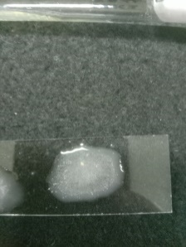  Bubbles  + |  | 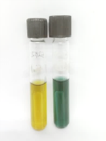  Control  + |  | 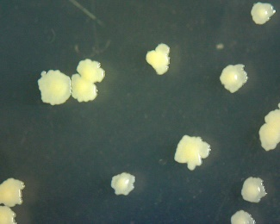  + |  | Not Tested
2 | C72.3 |  | 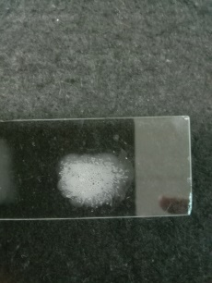  Bubbles  + |  | 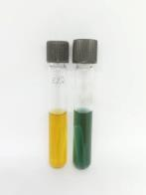  Control  + |  | 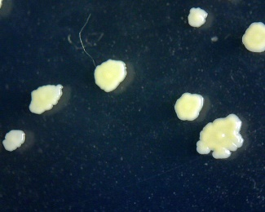  + |  | Not Tested
3 | LB2.2 |  | 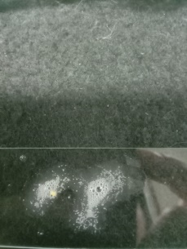  Bubbles  + |  | 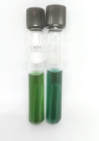  Control  - |  | 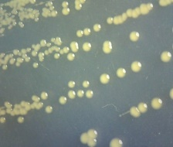  + |  | 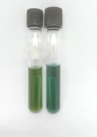  Control  -
4 | LB2.3 |  | 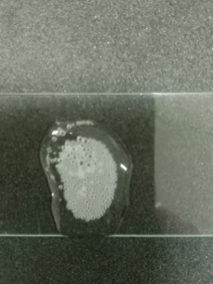  Bubbles  + |  | 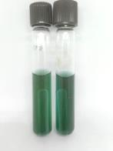  Control  - |  | 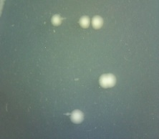  - |  | Not Tested
5 | LB3.2 |  | 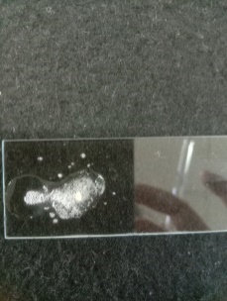  Bubbles  + |  | 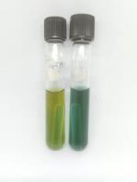  Control  - |  | 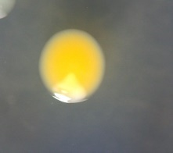  + |  | 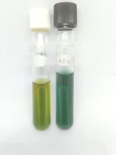  Control  -
6 |  | LB3.5 |  | 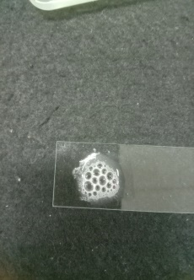  Bubbles  + |  | 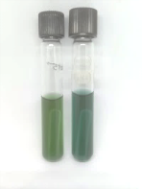  Control  - |  | 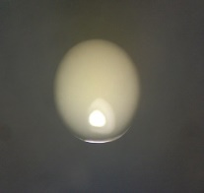  - |  | Not Tested
7 |  | LB3.6 |  | 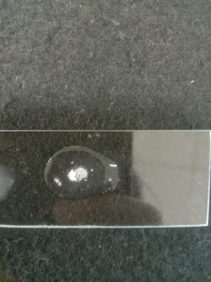  Bubbles  + |  | 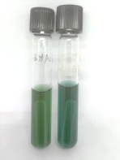  Control  - |  | 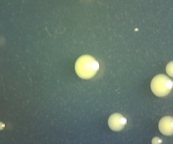  + |  | 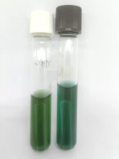  Control  -
8 |  | RB1.1 |  | 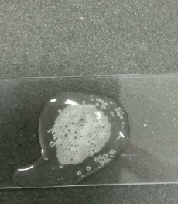  Bubble  + |  | 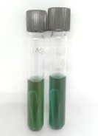  Control  - |  | 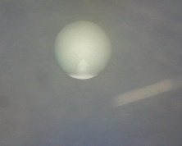  - |  | Not Tested
9 |  | RB1.2 |  | 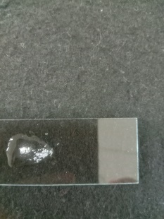  Bubble  + |  | 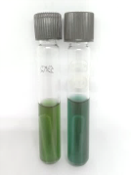  Control  - |  | 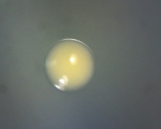  + |  | 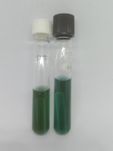  Control  -
10 |  | RB1.3 |  | 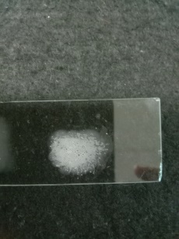  Bubble  + |  | 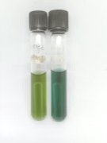  Control  - |  | 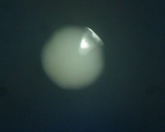  - |  | Not Tested

Note : Isolate codes represent bacterial isolates obtained from fecal samples of semi-wild long-tailed macaques from Tinjil Island. Isolates include C72.2 (Cage 7 Sample 2 Isolate 2), C72.3 (Cage 7 Sample 2 Isolate 3), LB2.2 (Left Base camp Sample 2 Isolate 2), LB2.3 (Left Base camp Sample 2 Isolate 3), LB3.2 (Left Base camp Sample 3 Isolate 2), LB3.5 (Left Base camp Sample 3 Isolate 5), LB3.6 (Left Base camp Sample 3 Isolate 6), RB1.1 (Right Base camp Sample 1 Isolate 1), RB1.2 (Right Base camp Sample 1 Isolate 2), RB1.3 (Right Base camp Sample 1 Isolate 3). Type of biochemical tests: Ca(Catalase: (+) bubbles, (-) no bubbles); M(Mannitol: (+) yellow+bubbles in durham tube, (-) green); Y(Yellow pigment ); G(Glucose: (+)yellow+bubbles in durham tube, (-) green).

Table S5 Biochemical tests (Endospore stain, acid fast stain, and Catalase test) on bacterial isolates of Gram-positive bacilli

No | Isolate code | Biochemical Tests
 |  | E | Af | Ca
1 | C72.1 | 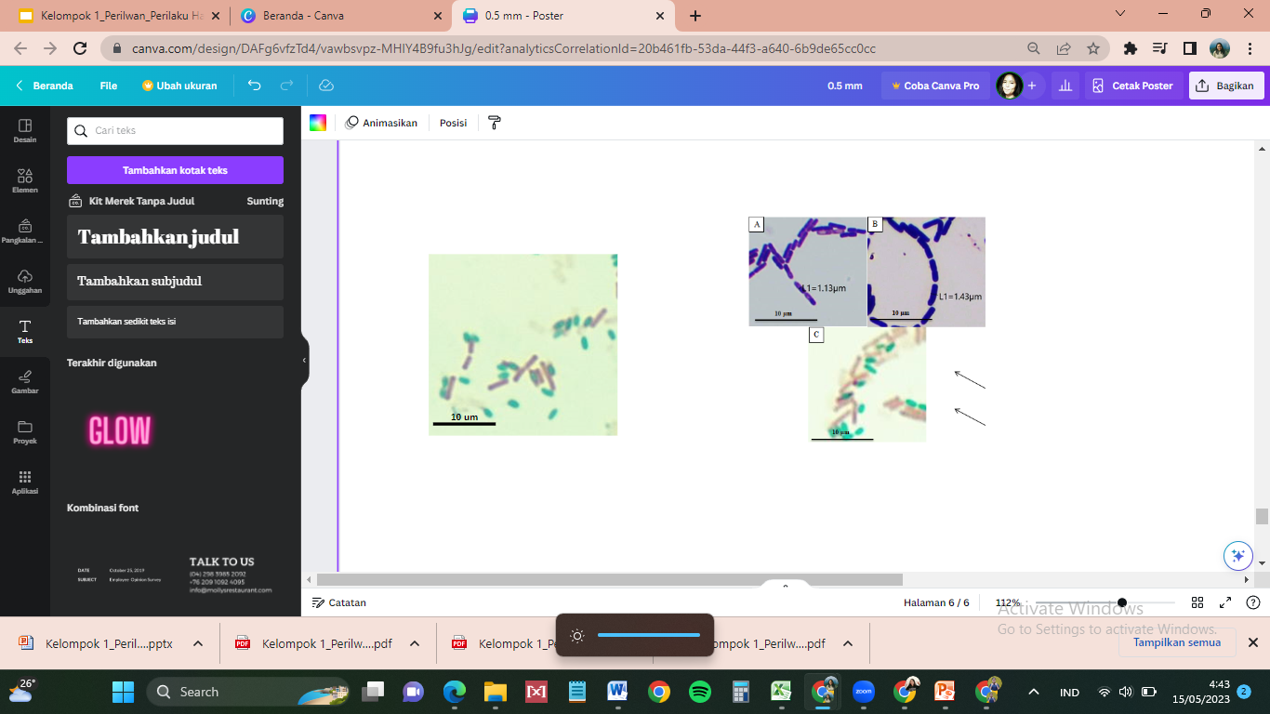  E  FS  V  Swollen cell  (E >V; FS>V) | Not Tested | 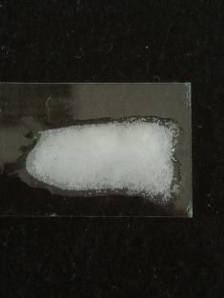  Bubble  +
2 | LB2.1 | 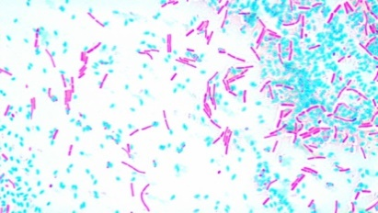  V  FS  + | Not Tested | 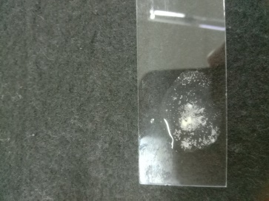  Bubble  +
3 | LB2.4 | 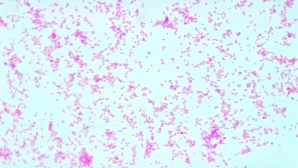  - | 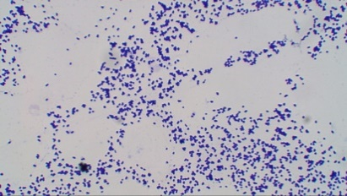  - | 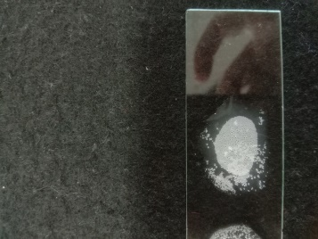  Bubble  +
4 | LB2.5 | 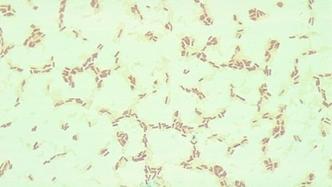  - | 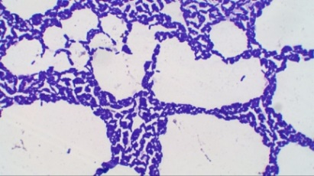  - | 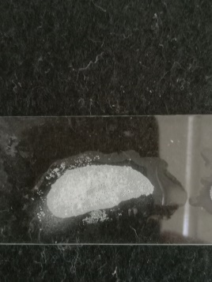  Bubble  +
5 | LB3.1 | 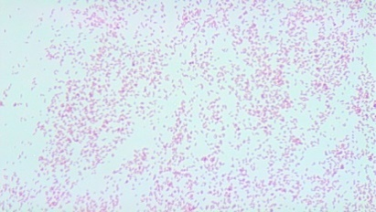  - | 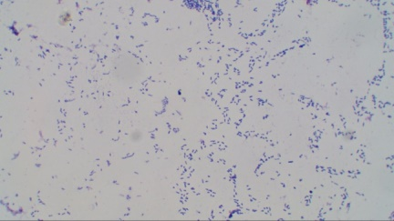  - | 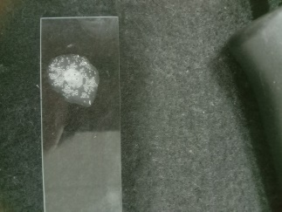  Bubble  +
6 | LB3.3 | 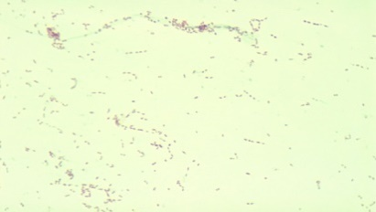  - | 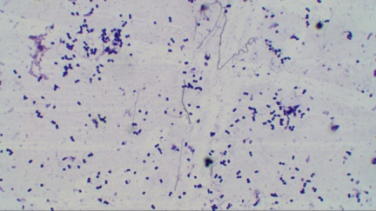  - | 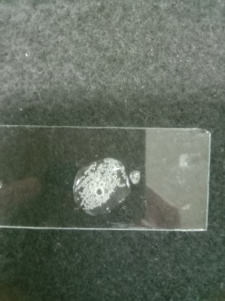  Bubble  +
7 | LB3.4 | 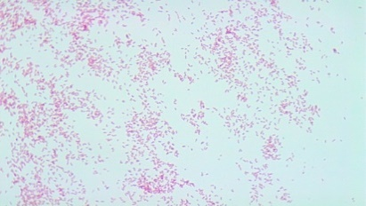  - | 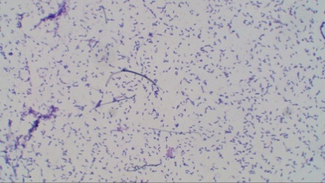  - | 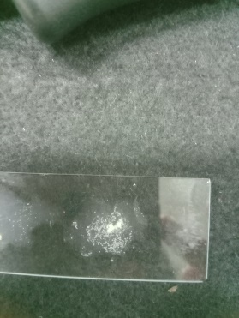  Bubble  +
8 | RB1.4 | 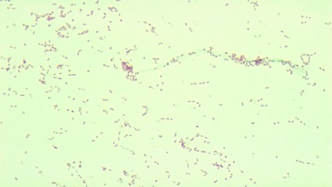  - | 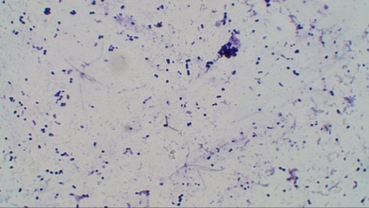  - | 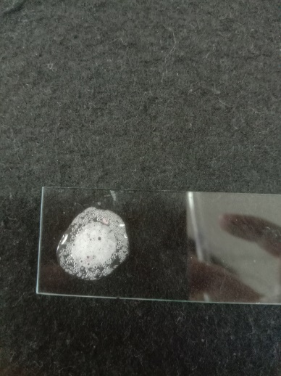  Bubble  +
9 | RB1.5 | 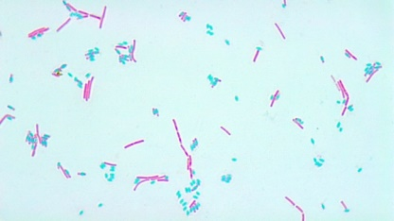  ES  V  FSE  + | Not Tested | 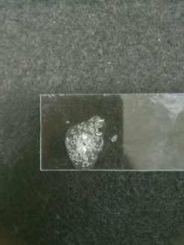  Bubble  +
Note: Isolate codes represent bacterial isolates obtained from fecal samples of semi-wild long-tailed macaques from Tinjil Island. Isolates include C72.1 (Cage 7 Sample 2 Isolate 1), LB2.1 (Left Base camp Sample 2 Isolate 1), LB2.4 (Left Base camp Sample 2 Isolate 4), LB2.5 (Left Base camp Sample 2 Isolate 5), LB3.1 (Left Base camp Sample 3 Isolate 1), LB3.3 (Left Base camp Sample 3 Isolate 3), LB3.4 (Left Base camp Sample 3 Isolate 4), RB1.4 (Right Base camp Sample 1 Isolate 4), RB1.5 (Right Base camp Sample 1 Isolate 5). Type of biochemical tests E(Endospore stain: (+) endospore-forming, (-) non-endospore forming), Af(Acid-fast: (+) red cells, (-) blue cell, Ca(Catalase (+) bubbles, (-) no bubbles). (E) Endospore, (FS) Free spore, (V) Vegetative.

Table S6 Biochemical tests (Voges-Proskauer, Cell diameter, Motility, NaCl) on bacterial isolates of Gram-positive bacilli
No |  | Isolate Code | Biochemical Tests
 |  |  | VP | Cd | Mo | Na
1 |  | C72.1 | 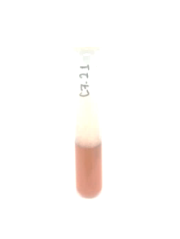  - | Not Tested | Not Tested  Control - | 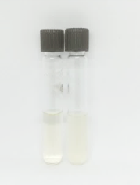  -
2 |  | LB2.1 | 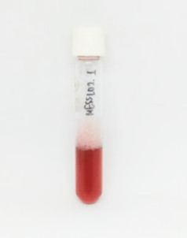  + | 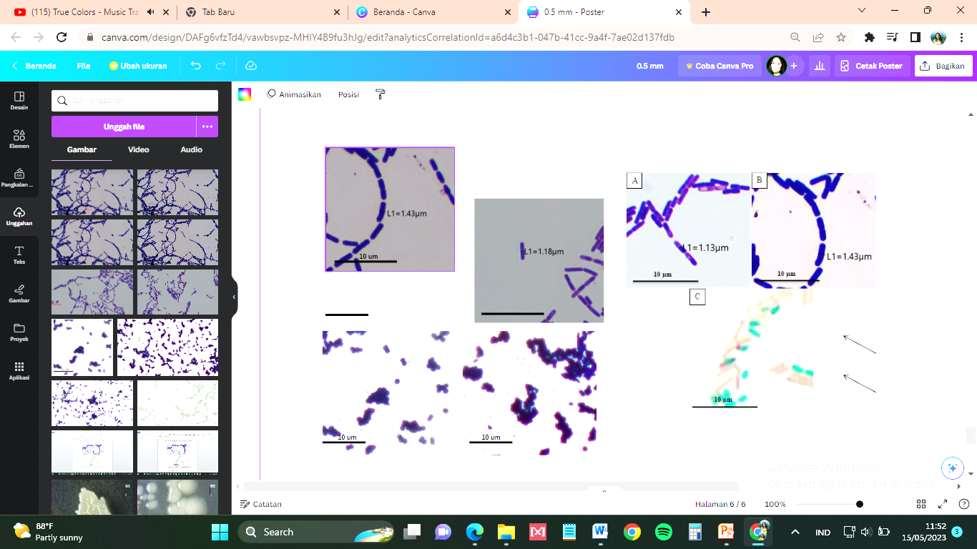  +  Cell diameter > 1 um | (Observation under the microscope)  + | Not Tested
3 |  | LB2.4 | Not Tested | Not Tested | Not Tested | Not Tested
4 |  | LB2.5 | Not Tested | Not Tested | Not Tested | Not Tested
5 |  | LB3.1 | Not Tested | Not Tested | Not Tested | Not Tested
6 |  | LB3.3 | Not Tested | Not Tested | Not Tested | Not Tested
7 |  | LB3.4 | Not Tested | Not Tested | Not Tested | Not Tested
8 |  | RB1.4 | Not Tested | Not Tested | Not Tested | Not Tested
9 |  | RB1.5 | 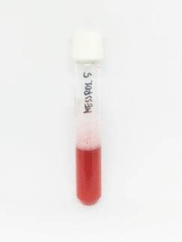+ | 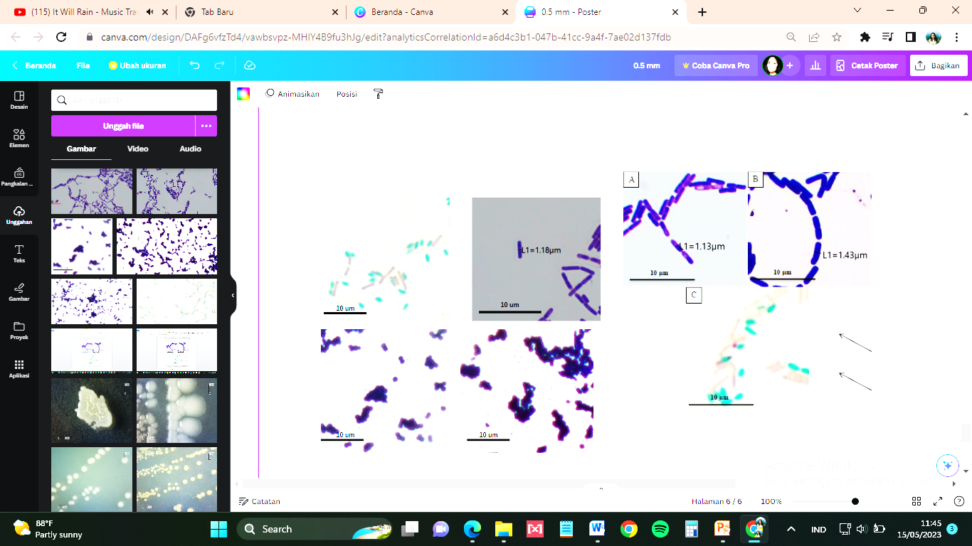  +  Cell diameter > 1 um | (Observation under the microscope)  + | Not Tested
Note : Isolate codes represent bacterial isolates obtained from fecal samples of semi-wild long-tailed macaques from Tinjil Island. Isolates include C72.1 (Cage 7 Sample 2 Isolate 1), LB2.1 (Left Base camp Sample 2 Isolate 1), LB2.4 (Left Base camp Sample 2 Isolate 4), LB2.5 (Left Base camp Sample 2 Isolate 5), LB3.1 (Left Base camp Sample 3 Isolate 1), LB3.3 (Left Base camp Sample 3 Isolate 3), LB3.4 (Left Base camp Sample 3 Isolate 4), RB1.4 (Right Base camp Sample 1 Isolate 4), RB1.5 (Right Base camp Sample 1 Isolate 5). Type of biochemical: VP(Voges-Proskauer: (+) red, (-) oranye/brown), Cd (Cell diameter: (+) Cd > 1 um, (-) Cd < 1 um), M(Motility test: (+) motile, (-) nonmotile), Na(NaCl 6.5%: (+) cloudy, (-) almost clear/same with negative control).

