A morphometric survey among three Iranian Turkoman, Kurdish and Caspian horse with Principal component analysis
Milad Hoseini ¹, Hossein Moradi Shahrbabak ², Bagher Zandi Mohamad ³, Mohamad Fahahi ⁴
1 Department of Animal Science, Faculty of Agriculture and Natural Resources, University of Tehran, Karaj, Iran, milad.hosseiny88@gmail.com, +989367607802
2 Department of Animal Science, Faculty of Agriculture and Natural Resources, University of Tehran, Karaj, Iran, hmoradis@ut.ac.ir, +989133915306
3 Department of Animal Science, Faculty of Agriculture and Natural Resources, University of Tehran, Karaj, Iran, m.b.zandi.b.m@gmail.com, +989354893596
4 Department of Animal Science, Faculty of Agriculture and Natural Resources, University of Tehran, Karaj, Iran, Mohammad.falahi@ut.ac.ir, +989188785570
*Correspond author: hmoradis@ut.ac.ir +989133915306
ABSTRACT
Three Iranian horse breeds, Turkoman, Caspian and Kurdish are the most important Iranian horse breeds which are well known in all around of the world; because of their beauty, versatility, great stamina and intelligence. In order to study on three horse breeds Turkoman, Kurdish and Caspian in Iran, a total of 191 purebred horses were sampled from some provinces of Iran. Twenty-three morphometric traits were selected. The results of our investigation represented the breeds had morphometric difference. According to results of CDA, PCA and cluster analysis, Caspian had smaller size in most variables and it was detached clearly from the others. The most variable trait was Hind Hoof Length among the breeds. Adaption with different environments causes difference in morphology. Presence of high variability in the mentioned trait implies environment affected it more than the other traits.
Key words: Morphometric, Iran, horse, Breed, PCA

1. INTRODUCTION
Native horse breeds are national precious wealth in each country, keeping and rearing of them is valuable (Hendricks 2007). Breeds Turkoman, Kurdish and Caspian are the most important Iranian breeds which are used for different. Turkoman breed is used in order to jumping and course, because of its beauty, great endurance and speed. Caspian, as one of the oldest breeds, is used for riding, training to children, because of its small body. These beautiful ponies have strength, speed and great versatility making them a wonderful all round pony. Kurdish breed could be used in chogan and deressage because of its bravery.
Distribution of each species might is not uniform and it may include different breeds, usually all of which appear with different morphology and biology. In the viewpoint of the environment, ignoring inner species diversity, like presence of different breeds, could result the species in peril (Ruggiero, Aubry et al. 1999). One of the best methods in investigations of horse breeds is morphometric method. Comparing to molecular method, this method has noticeable advantages including low cost, absence of pollution, easy to study as well as elimination of personalization deal (Pavlinov 2001). The same is true for horse breeds from many years age (Hendricks 2007).
So far some studies took place associated with horse morphometric. By the way, Gabriel, Jolly et al. 1998 revealed significant differences of equine navicular bone among different horse breeds (Gabriel, Jolly et al. 1998). Also Cervantes, Baumung et al. 2009 discovered significant differences in shape and size of the Arabian horse in Spain (Cervantes, Baumung et al. 2009). One of the most important studies associated with morphometric of horse breeds belongs to Brooks, Makvandi‐Nejad et al. 2010 study in which 65 horse breeds, including Caspian breed, were investigated (Brooks, Makvandi‐Nejad et al. 2010). According to their result Caspian was near to such breeds as the Welsh Mtn. Pony, Welsh pony and Shetland pony. In another study Weller, Pfau et al. 2006 showed a significant difference of joint angles and segment lengths among racehorses in France and Ireland (Weller, Pfau et al. 2006). Morphometric studies of horse breeds were not limited to outer body organs. So that, ÇLelimli, Seyrek‐Intas et al. 2004 revealed that tendon/ligament measures of Thoroughbreds were significantly higher than Arabian horse (ÇLelimli, Seyrek‐Intas et al. 2004).
All of the above mentioned studies were applied to reply this question whether there is any morphometric difference among horse breeds? If so, how it is? By this way, better Identification of breeds, their evolution process as well as their sibling relationship could be obtained.
Therefore, aim of this investigation is assessing presence and how to morphometric difference as well as sibling relationships among Iranian breeds Turkoman, Kurdish and Caspian.
2. MATERIALS AND METHODS
This investigation was carried out based on a total of 191 purebred horses belonging to three breeds; Turkoman (70 individuals), Kurdish (77 individuals) and Caspian (44 individuals), which were oriented from provinces Alborz, Tehran, Kurdistan, Kermanshah, Hamadan, Gilan, Golestan, Markazi and Isfahan.
Twenty-three morphometric traits were chosen by standard caliper and measuring tapes (Figure 1). As Figure 1 shows, morphometric variables are as follows:
Head Length (1), Ear Length (2), Length (3), Height (4), Fore arm Length (5), Fore Cannon Length (6), Fore Pastern Length (7), Fore Hoof Length (8), Fore Cannon Midpoint Circumference (9), Fore Pastern Circumference (10), Space Under Horse (11), Length, Croup to Dock (12), Gaskin Length (13), Hind Cannon Length (14), Hind Pastern Length (15), Hind Hoof Length (16), Hind Cannon Midpoint Circumference (17), Hind Pastern Circumference (18), Barrel Girth, at Heart (19), Circumference at base (20), Eye to Eye Width (21), Chest Width (22), Pelvis Width Distance (23).
In order to proofing presence of difference among the breeds, Multivariate analysis of variance (MANOVA) was implemented. Also Canonical Discriminate Analysis (CDA), Principal Component Analysis (PCA) and Custer analysis were executed for assessing relationship among the breeds. Analysis of variance (ANOVA) was done individually for each morphometric variable in order assessing presence of difference in each variable among the breeds. All statistical analysis was executed by SAS statistical program, V. 9.1 (SAS Institute, 2003).

Insert figure1

3. RESULTS
MANOVA demonstrated a high significant difference among the breeds (Wilks' Lambda: 0.0048, F: 36.69, df1: 46, df2: 126, P<0.0001). A scatter plot of CDA revealed that the breeds were apart to each other (Figure 2). The same is true for PCA.
According to PCA, Hind Hoof Length had the most contribution in PC1 (Table 1). Scatter plot based on PC1 (component 1) and PC2 (component 2) (from 70% of the total variance) showed that the breeds were utterly separated with each other; Caspian was placed thoroughly separated from each other, Turkoman and Kurdish were close to each other and they had a little bit overlap (Figure 3). Cluster analysis confirmed the results of PCA. So that according to this analysis, Caspian breed was placed in a separated cluster, Turkoman and Kurdish breeds were placed in a unit cluster (Figure 4). The most and the least morphological distance was between Caspian with Turkoman and Kurdish with Caspian, respectively (Figure 5). Table 2 indicates means of all morphometric traits plus their standard deviation for each breed. ANOVA revealed significant differences in all features, but three variables Eye to Eye Width, Fore Hoof Length and Hind Hoof Length.
In all significant variants Caspian had lower mean rather than the others. So, it could be concluded that Caspian has smaller size over than the others. Also a means of Kurdish and Turkoman were close to each other in most of the traits (Table 2).
Insert figure 2
Insert figure 3
Insert figure 4
Insert figure 5
Insert table1
Insert table2
DISSCUTION
Our investigation suggested the presence of significant difference among three breeds Turkoman, Kurdish and Caspian. Other authors have shown results same as our results. With respect to histomorphometryic, Gabriel et al., 1998 during a morphometric investigation among horse breeds revealed that the smallest of equine navicular bone in ponies and horses was belonging to low weight pony and hybrid racehorse, respectively (Gabriel et al., 1998). The biggest of equine navicular bone was belonging to high weight hybrid. Cortical bone had been increased in racehorse in order for production of Cancellus bone; subsequently it would lead to an increase of production of bone in Corticoendosteal junction (Baggot, and Russel, 1988). Also in another histomorphometryic survey, it shows that tendon/ligament measures of Thoroughbreds were significantly larger than Arabian horse (Celimli et al., 2004). In respect of outer body organ morphometric morphometric, Weller et al., 2006 demonstrated significant difference among racehorses in France and Ireland in joint angles and segment lengths (Weller et al., 2006). Concerning single breed morphometric investigations, Cervantes et al., 2009 showed the presence of significant difference in shape and size of the Arabian horse in Spain (Cervantes et al., 2009).
The results of this study demonstrated that Caspian had utterly smaller size and different morphometric appearance rather than the others. On the other hand Kurdish and Turkoman were similar to each other. This result could be justified by natural selection. Body size is critically important trait in nearly all horse breeds and is presumably under strong selection. Natural selection selects for complex trait like body size to improve function and breed’s fitness. In many cases different environments creates different species and breeds, usually with different morphology. The more different the environmental conditions are, the more different the morphological traits among species would be. Turkoman and Kurdish have the same habits rather than Caspian. It leads to resemblance between Turkoman and Kurdish and more morphological difference of Caspian. Also paleontological investigations demonstrate that primitive horses had the same size as dogs. But same is not true for nowadays and it shows size evolution of horses. Therefore horse size is a factor in which there is possibility of its variability among different breeds because against environment. By the way, in Brooks, Makvandi‐Nejad et al. 2010 study Caspian was classified alongside breeds Welsh Mtn. Pony, Welsh pony and Shetland pony, amongst 65 horse breeds (Brooks, Makvandi‐Nejad et al. 2010).
According to PCA, Hind Hoof Length had the most contribution in changing. It suggested that Hind Hoof Length is a valuable feature for morphometric studies in horses. On the other extreme this result shows that Hind Hoof Length is more variable than other features. By the way, Sobczuk and Komosa 2012 demonstrated the largest discriminative power in PCA (Sobczuk and Komosa 2012), in order to discrimination of Polish Arabian horses among three leading stud farms, was belonging to length of the metatarsus, pelvis, arms and the depth of the chest and neck. Reason of the high variability of Hind Hoof Length in our results might be explained by breeds fitness. Environmental adaptation ensures that once the attributes of the species have provided themselves effective the species will persist. Presence of high variability in Hind Hoof Length implies environment affected it more than the other traits. Due to relationship between changes of Hind Hoof Length and horse speed and jumping ability, it could be concluded presence of difference among habits and application among the breeds, and subsequently difference among jumping and speed ability, resulted in this variability in this trait.
All in all, evolution of horse caused traits size changing among the breeds and this evolution was in direction of adaption with the nature and fitness.
4. CONCLUSIONS
The our results suggested the presence of morphometric difference among three Iranian horse breeds, Turkoman, Kurdish and Caspian. So that Caspian had smaller size than the others and it was separated from each other based on 23 morphometric traits. The most variable trait among the breeds was Hind Hoof Length.
REFRENCES
1. Baggot, D.G, Russel A.M. 2007 Lameness in dairy cattle. British Veterinary Journal. 137; 114-132.
2. Brooks SA, Makvandi‐Nejad S, Chu E, Allen JJ, Streeter C, Gu E, McCleery B, Murphy BA, Bellone R, Sutter NB. 2010 Morphological variation in the horse: defining complex traits of body size and shape. Animal genetics. 41; 159-165.
3. Cervantes I, Baumung R, Molina A, Druml T, Gutiérrez JP, Sölkner J, Valera M. 2009 Size and shape analysis of morphofunctional traits in the Spanish Arab horse. Livestock Science. 125; 43-49.
4. ÇLelimli N, Seyrek‐Intas D, Kaya M. 2004 Morphometric measurements of flexor tendons and ligaments in Arabian horses by ultrasonographic examination and comparison with other breeds. Equine Veterinary Education. 16; 81-85.
5. Gabriel A, Jolly S, Detilleux J, Dessy-Doizé C, Collin B, Reginster J. 1998 Morphometric study of the equine navicular bone: variations with breeds and types of horse and influence of exercise. Journal of anatomy. 193; 535-549.
6. Hendricks B L. International encyclopedia of horse breeds. 2007 1st ed. Oklahoma, USA, University of Oklahoma Press Publisher.
7. Pavlinov I Y. 2001. Geometric morphometrics, a new analytical approach to comparison of digitized images. Information Technology in Biodiversity Resarch. 41-90.
8. Ruggiero L F, Aubry K B, Buskirk S W, Koehler G M, Krebs C J, McKelvey K S, Squires J R. 1999 Ecology and conservation of lynx in the United States. Rocky Mountain Mesearch Station. 1; 351-371.
9. SAS Institute. 2003 SAS software. Version 9.1. SAS Inc. Cary NC.
10. Sobczuk D, Komosa M. 2012 Morphological differentiation of Polish Arabian horses-multivariate analysis. Bulletin of the Veterinary Institute in Pulawy. 56; 623-629.
11. Weller R, Pfau T, May SA, Wilson AM. 2006 Variation in conformation in a cohort of National Hunt racehorses. Equine veterinary journal 38; 616-621.

Table 1. Contribution of each morphometric variable in three first components, the percentages within each component indicate contribution of each component in changes
PC3 (6%) | PC2 (10%) | PC1 (60%) | Component  Variables
-0.015 | -0.156 | 0.238 | Head Length
0.034 | 0.008 | 0.235 | Eye to Eye Width
-0.314 | -0.081 | 0.174 | Ear Length
0.072 | 0.283 | 0.182 | Neck Circumference
0.495 | -0.036 | 0.172 | Neck Length
-0.48 | 0.05 | 0.196 | Chest Width
0.063 | -0.055 | 0.256 | Withers Height
0.062 | 0.015 | 0.213 | Barrel Girth
0.268 | -0.053 | 0.123 | Fore arm Length
0.072 | 0.151 | 0.232 | Fore Cannon Length
-0.07 | 0.094 | 0.202 | Fore Pastern Length
0.097 | -0.012 | 0.252 | Fore Cannon Midpoint Circumference
0.14 | 0.034 | 0.241 | Fore Pastern Circumference
0.195 | 0.556 | -0.0631 | Fore Hoof Length
-0.012 | -0.274 | 0.214 | Space Under Horse
-0.314 | 0.218 | 0.2096 | Pelvis Width Distance
0.163 | -0.089 | 0.241 | Length Croup to Dock
-0.311 | 0.191 | 0.197 | Gaskin Length
-0.056 | 0.064 | 0.246 | Hind Cannon Length
0.14 | -0.1136 | 0.235 | Hind Cannon Midpoint Circumference
-0.034 | 0.121 | 0.219 | Hind Pastern Length
0.072 | -0.0342 | 0.242 | Hind Pastern Circumference
0.098 | 0.581 | -0.402 | Hind Hoof Length

Table 2. Basic statistics of the main morphometric features, * and ** indicates signification in levels 0.05 and 0.01 respectively, based on ANOVA
All breeds | Caspian |  | Kurdish |  | Turkoman |  | Breed
Mean | Std Dev | Mean | Std Dev | Mean | Std Dev | Mean | Variable
51.21 | 4.3 | 44.9 | 2.65 | 52.84 | 2.6 | 55.9 | Head Length**
16.38 | 2.5 | 14.83 | 1.22 | 16.9 | 1.02 | 17.42 | Eye to Eye Width^{ns}
13.01 | 1.3 | 11 | 1.64 | 13.9 | 1.05 | 14.14 | Ear Length*
68.50 | 4.7 | 61.2 | 6.62 | 73.4 | 5.2 | 70.91 | Neck Circumference**
65.18 | 9.7 | 57.04 | 10.034 | 70.01 | 11.2 | 68.51 | Neck Length**
33.26 | 2.6 | 19.31 | 8.7 | 43.5 | 3.8 | 36.97 | Chest Width*
136.60 | 10.78 | 119.32 | 6.9 | 140.93 | 7.5 | 149.61 | Withers Height**
154.95 | 9.1 | 133.75 | 13.21 | 163 | 13.8 | 168.1 | Barrel Girth**
41.95 | 7.4 | 36.3 | 3.6 | 42.4 | 6.9 | 47.17 | Fore arm Length*
25.17 | 2.001 | 21.41 | 2.6 | 27.1 | 2.001 | 27 | Fore Cannon Length*
10.52 | 1.4 | 8.11 | 1.6 | 11.68 | 1.42 | 11.78 | Fore Pastern Length*
16.56 | 1.1 | 14.3 | 1.2 | 17.225 | 1.22 | 18.16 | Fore Cannon Midpoint Circumference*
16.29 | 1.25 | 14.12 | 1.23 | 16.92 | 1.34 | 17.83 | Fore Pastern Circumference*
6.64 | 1.3 | 7.02 | 0.92 | 6.51 | 1.6 | 6.41 | Fore Hoof Length^{ns}
76.17 | 9.75 | 62.51 | 7.2 | 78.366 | 7.03 | 87.66 | Space Under Horse**
46.16 | 5 | 35.2 | 6.95 | 54.465 | 6.2 | 48.82 | Pelvis Width Distance**
46.04 | 6.6 | 34.74 | 4.61 | 54.6 | 6.24 | 48.78 | Length, Croup to Dock**
45.08 | 4.44 | 42.21 | 4.5 | 41.8 | 3.48 | 51.23 | Gaskin Length**
41.39 | 4.92 | 29.1 | 4.9 | 54.6 | 7.03 | 40.48 | Hind Cannon Length**
25.44 | 1.9 | 15.72 | 1.9 | 40.3 | 1.36 | 20.3 | Hind Cannon Midpoint Circumference**
12.98 | 1.94 | 8.1 | 1.3 | 18.5 | 1.94 | 12.35 | Hind Pastern Length*
15.29 | 1.43 | 15.05 | 1.31 | 11.74 | 1.57 | 19.1 | Hind Pastern Circumference**
6.63 | 0.8 | 7 | 1.13 | 6.75 | 1.49 | 6.15 | Hind Hoof Length^{ns}

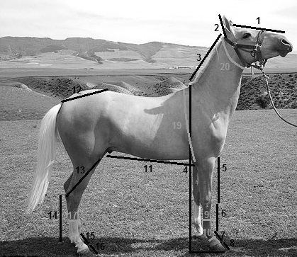
Figure 1. Morphometric traits, Numbering consistent with the text (missing features: 21, 22, 23)
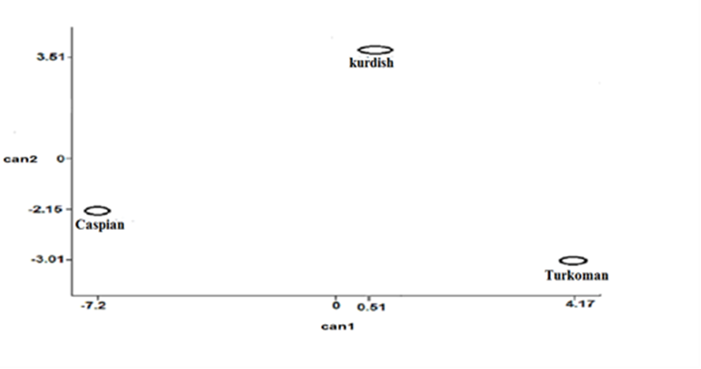
Figure 2. Scatter plot of CDA based on can1 and can2
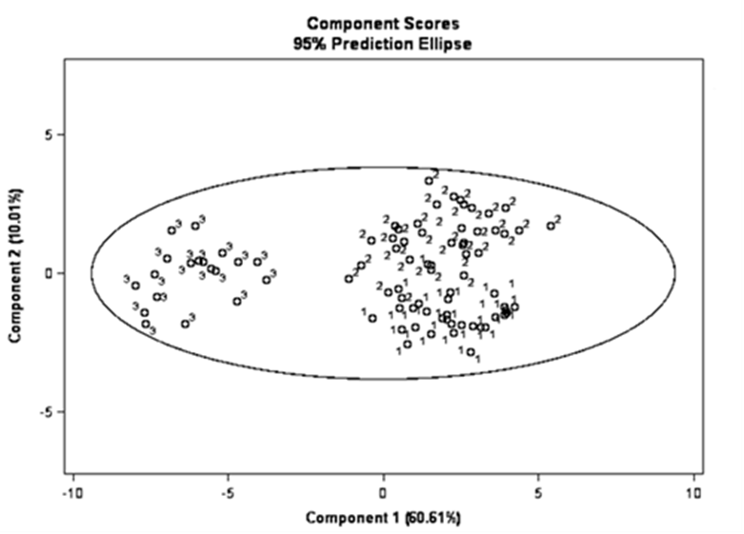
Figure 3. Scatter plot of PCA base on PC1 and PC2, the numbers 1, 2 and 3 are indication breeds Turkoman, Kurdish and Caspian, respectively.
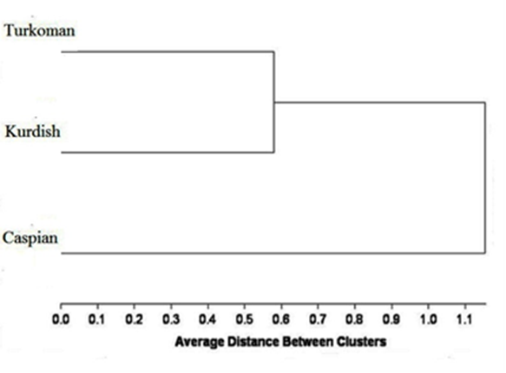
Figure 4. Dendrogram plotted by UPGMA method based on cluster analysis among the breeds
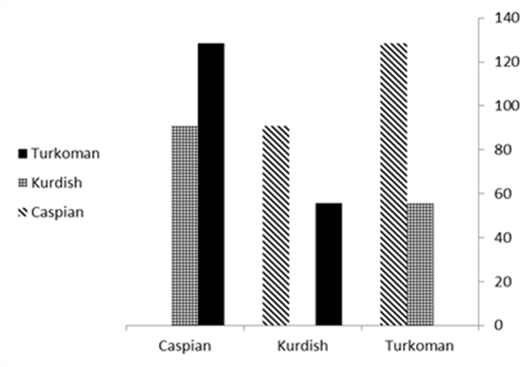
Figure 5. Squared mahalonobis distances among the breeds

