FORM A
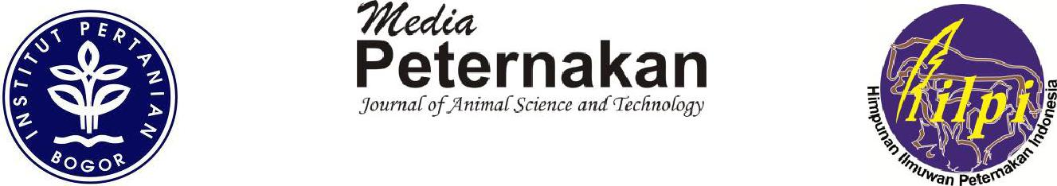

Faculty of Animal Science Building, Bogor Agricultural University
Jln. Agatis, Kampus IPB Darmaga, Bogor Indonesia 16680

Phone/Fax: +62 251 8421692
E-mail: mediapeternakan@yahoo.co.id, mediapeternakan@ipb.ac.id

Website: http://medpet.journal.ipb.ac.id/, http://journal.ipb.ac.id/index.php/mediapeternakan

Statement of Originality

To:

Editorial Board of Media Peternakan
Faculty of Animal Science,

Bogor Agricultural University

Herewith we submit a manuscript,

Title : Embryo Development and Post-Hatch Performance of Kampung Chicken By In Ovo Feeding of L-Arginine

Author (s) | : | 1. Muhammad Azhar
 |  | 2. Djoni Prawira Rahardja
 |  | 3. Wempie Pakiding
Institution | : | 1. Science and Technology of Animal Agriculture, Graduate School, Hasanuddin University
 |  | 2. Department of Animal Agriculture, Faculty of Animal Agriculture, Hasanuddin University
 |  | 3. Department of Animal Agriculture, Faculty of Animal Agriculture, Hasanuddin University

To be published in Media Peternakan. We declare that the content of this manuscript or a major portion thereof has not been published, that it is not being submitted for publication elsewhere, and it will not be submitted to any media during the review process, unless we have officially withdrawn the manuscript from Media Peternakan on a letter containing relevan reasons signed by all of authors.

We agree to follow the entire process of manuscript selection in accord to Media Peternakan procedures, including revising the manuscripts by following the Editor and Reviewers comments in a specified time. We understand and agree that if does not follow the rules will be disqualified for publishing manuscript in MP for 2 consecutive years since the letter issued.

We declare that all listed names are entitled to become an author and all have agreed the final form of submitted manuscripts.

FORM A

Faculty of Animal Science Building, Bogor Agricultural University
Jln. Agatis, Kampus IPB Darmaga, Bogor Indonesia 16680

Phone/Fax: +62 251 8421692
E-mail: mediapeternakan@yahoo.co.id, mediapeternakan@ipb.ac.id

Website: http://medpet.journal.ipb.ac.id/, http://journal.ipb.ac.id/index.php/mediapeternakan

For correspondence, please contact us at:

Name : Muhammad azhar

Address : Perumahan Permata Sudiang Raya (PSR) J4/3, Makassar

Phone/e-mail : 081342482951

Thank you for your attention and collaboration.

Author : Muhammad Azhar E-mail : muhammadazhar030390@gmail.com

Author : Djoni Prawira Rahardja E-mail : djonipra@gmail.com

Author : Wempie Pakiding E-mail : pwempie@yahoo.com

FORM A

Faculty of Animal Science Building, Bogor Agricultural University
Jln. Agatis, Kampus IPB Darmaga, Bogor Indonesia 16680

Phone/Fax: +62 251 8421692
E-mail: mediapeternakan@yahoo.co.id, mediapeternakan@ipb.ac.id

Website: http://medpet.journal.ipb.ac.id/, http://journal.ipb.ac.id/index.php/mediapeternakan

Copyright Release Form

We are the authors of a manuscript,

Title | : | Embryo Development and Post-Hatch Performance of Kampung Chicken By In Ovo Feeding of L-Arginine
Author (s) | : | 1. Muhammad Azhar
 |  | 2. Djoni Prawira Rahardja
 |  | 3. Wempie Pakiding
Institution | : | 1. Science and Technology of Animal Agriculture, Graduate School, Hasanuddin University
 |  | 2. Department of Animal Agriculture, Faculty of Animal Agriculture, Hasanuddin University
 |  | 3. Department of Animal Agriculture, Faculty of Animal Agriculture, Hasanuddin University

agree to release to the Media Peternakan all control over the manuscript including rights to reproduce, to distribute, and to sell as part of the journal.

Author : Muhammad Azhar E-mail : muhammadazhar030390@gmail.com

Author : Djoni Prawira Rahardja E-mail : djonipra@gmail.com

Author : Wempie Pakiding E-mail : pwempie@yahoo.com

